Observation / Screenshots:
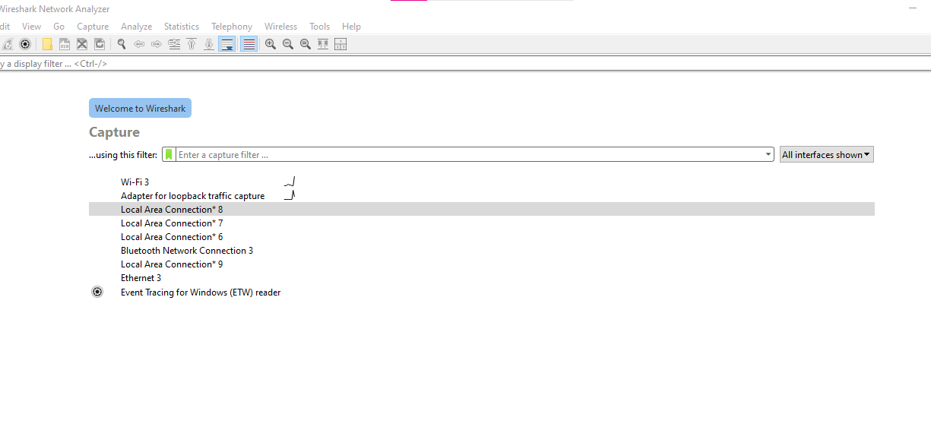
fig: Interface of Wireshark

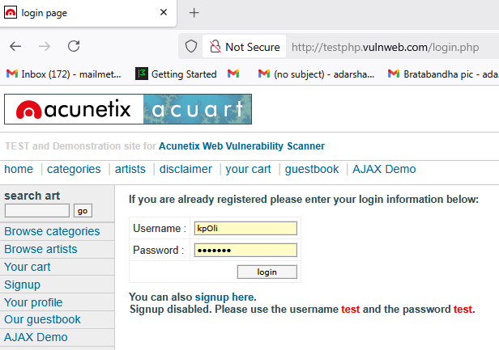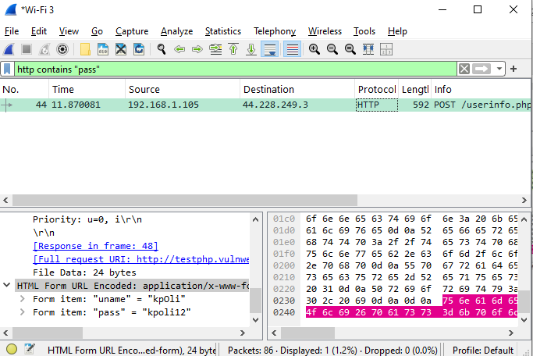
fig: http form fillup fig: http packet capturing with filter "pass"

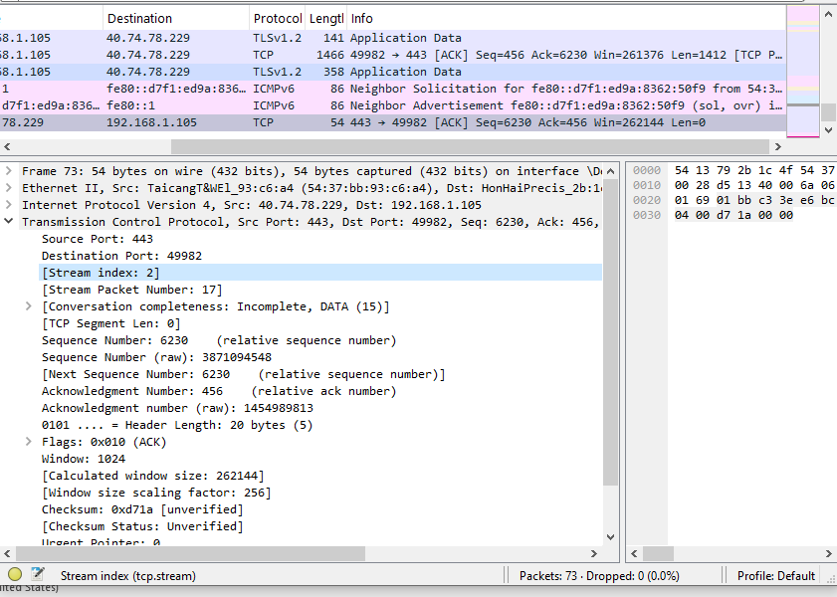
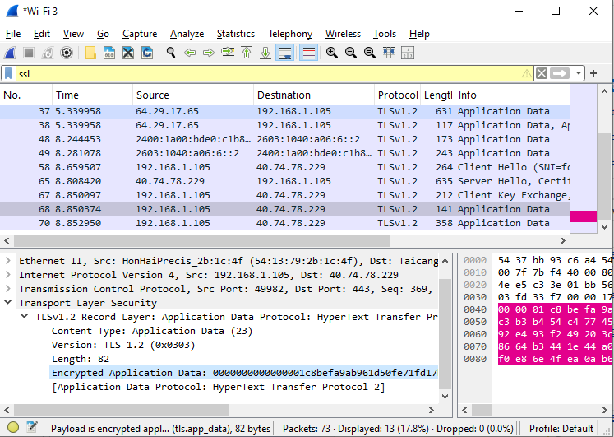
fig: Capturing https data using ssl filter

fig: TCP packet showing OSI Layers

